Installation Guide and Project Description for
LinqCommerce 3.0
An open source E-Commerce module using LINQ

By Joseph Anderson, MCP
09/21/2009

Table of Contents

Introduction 3
About the Project 3
What’s new in LinqCommerce 3.0 3
Store 4
Store Front 4
Administration 5
Configuration 6
Web.config Demystified 6
Section Group Element Properties 6
Installation 7
Installing Sitefinity CMS or ASP.NET Application 7
Configuration 7
Database 10
Connection String 10
PayPal Integration 10
Amazon Access ID 10
Amazon Search Index 10
Amazon Associates 11
Best Buy Remix API 11
Tutorials 11
Getting Started with the Admin 11
Introduction 11
Adding Products to the Admin 11
Tax and Shipping 11
Coupons 12
Inventory 12
Conclusion 13

Introduction
This whitepaper will discuss installing LinqCommerce as part of another ASP.NET application, such as the Sitefinity CMS, and discuss LinqCommerce’s general functionality. Ultimately, this tool will share the same database as the other application, so security and profile info will be the same, but LinqCommerce will have its own tables and stored procedures. In LinqCommerce 3.0, a back up of a database is included, so you can run this project and another ASP.NET application with two databases.

About the Project
This project’s purpose is to demonstrate the use of LINQ, especially in making an E-Commerce store. This should serve as a sample for other software developers implementing 3rd party e-Commerce applications into the Sitefinity CMS or another application.
Since this application would be placed inside of Sitefinity, or another ASP.NET application, no security has been implemented. This solution is not meant to be a commercial Sitefinity module, but rather an open source project that could be improved and used for the community. To run the project on its own, restore the back up, located in the App_Data folder, onto a blank database.
Portions of this open source project were adapted from Christian Darie’s E-Commerce book, “Beginning ASP.NET 2.0 E-Commerce in C# 2005.” From his book, the entire application was broken down into user controls, using LINQ for the Data Access Layer, and using some of Telerik’s RadControls for ASP.NET AJAX. I also used PayPal IPN code from XDev Info and advice from Rick Strahl’s article on Website Standard Pro.

What’s new in LinqCommerce 3.0
The following features have been added:
- Integration with PayPal Website Standard IPN, which enabled LinqCommerce to check off that an order has been completed after the user pays on PayPal. As a result, LinqCommerce can send the user an e-mail and send the seller another message with almost all of the user’s payment info.
- Code from .aspx and .ascx pages has been refactored and placed inside of classes in App_Code folder. This results in less code and code that’s easier to manage. All code is commented and open source.
- Various bug fixes throughout the system, including issues with product images, the shopping cart and coupons
- Simplified installation. Now, the system comes with a sample database with balloon images. So, you can run LinqCommerce on a separate database. I also included a Windows Installer, so you can create a Virtual Directory and put the project inside the wwwroot folder easier
- Added Ajax to administration area, improving performance

Store
The store has 3 main parts: a store front, an administration area and a configuration section.

Store Front
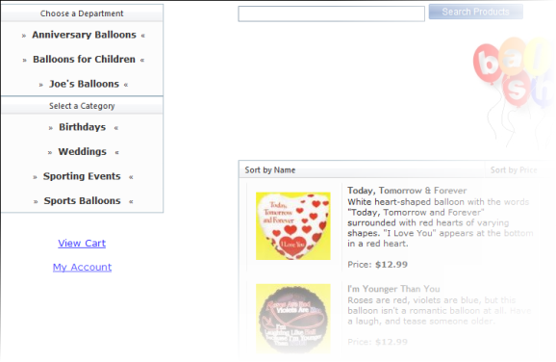
These files are contained in the LinqControls > ControlTemplates folder. When the user visits the store, he or she picks categories from a list on the left. When a user selects a department, the hyperlink control appends a department ID to the query string. From there, a list populates in the middle with product related to the department and category. Until the list has been drilled down to the end, the user will see products special promotion. The product list returns a certain number of records and paging is computed by the RadGrid products list. Users can also search by product, using the RadComboBox’s load on demand feature.
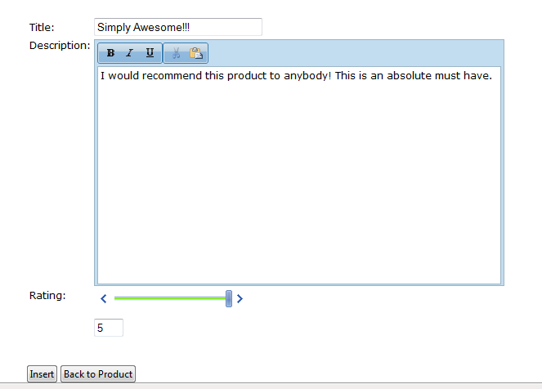
After a product is selected, the user is brought to the product details page. The user can add the product to the shopping cart, select a color, select a size or write a review. After a user submits a review, the admin must log-in, go to the reviews administration section, and check off the review as approved. The user can also read these comments and sort them based on score or date submitted. Then, the user can view products that other customers have purchased from the site or product recommendations from Amazon.com. If products from Amazon are purchased on the user’s site, then the store owner will get a purchase percentage from Amazon. For more info, please consult their website.
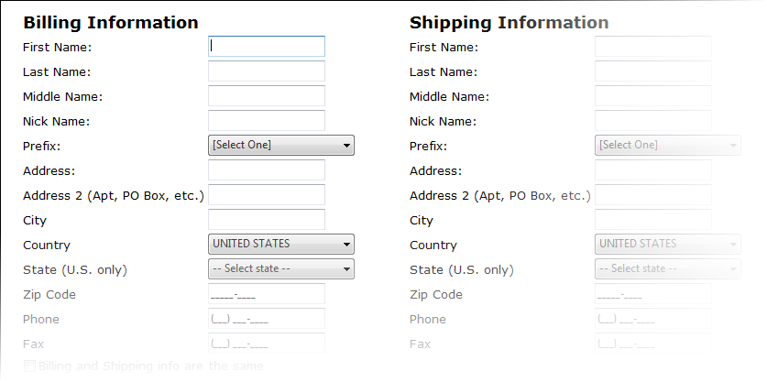
Users can also login to the store and view certain pages, such as being able to checkout. Users can complete their profile, recover or change their password using the security system. They can also track their orders. The ASP.NET 3.5 security controls were used for the project, so the entire API is the same from the .NET Framework.
When the user has finished shopping, he or she can click on the view cart link and go to the shopping cart. The cart is a RadGrid that pulls the shopping cart ID from session state. When a user adds items to the cart, LinqCommerce inserts database records and the cart ID links them all together. The cart will deactivate options to add quantity and checkout without records, based on a LINQ query. The cart will adjust quantity based on the row’s column and the price will adjust based on that number based on another LINQ query. Once the user clicks checkout, the cart’s information is passed to PayPal via a query string. LINQ takes care of retrieving the individual column names and sending them to PayPal based on certain parameters, such as a cart ID. For more info on these parameters, please read this article on PayPal HTML variables.

Administration
The store is administered in four main sections. These include the order catalog, shopping cart, coupon and order administration sections.
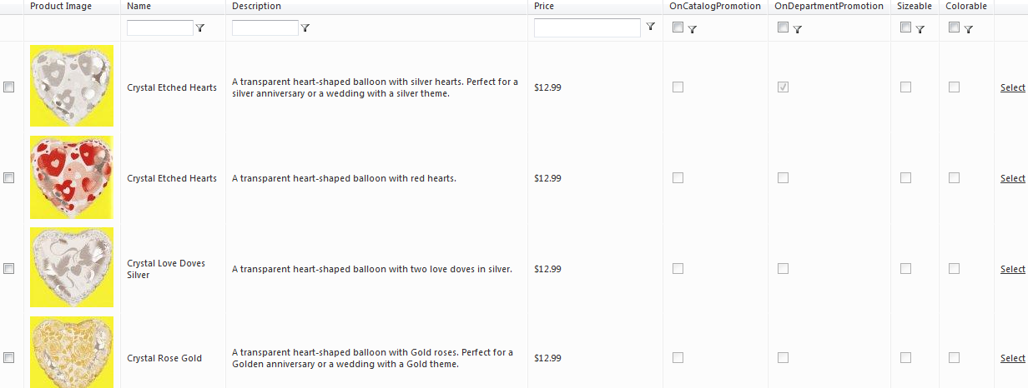
The product catalog is administered by a page called catalogadmin.aspx. Catalogadmin.aspx loads a user control based on query string fields. A list of departments appears first. When a department is selected, the hyperlink adds a department ID to the query string. A second grid appears showing categories within the department. The process repeats itself and a list of products is now shown based on that category.
There is also a shopping cart admin to empty out carts where the user never checked out. This is the equivalent of people shopping at your store, placing items in the cart, leaving the carts behind and leaving the store. This removes unnecessary data from the database and makes it smaller. 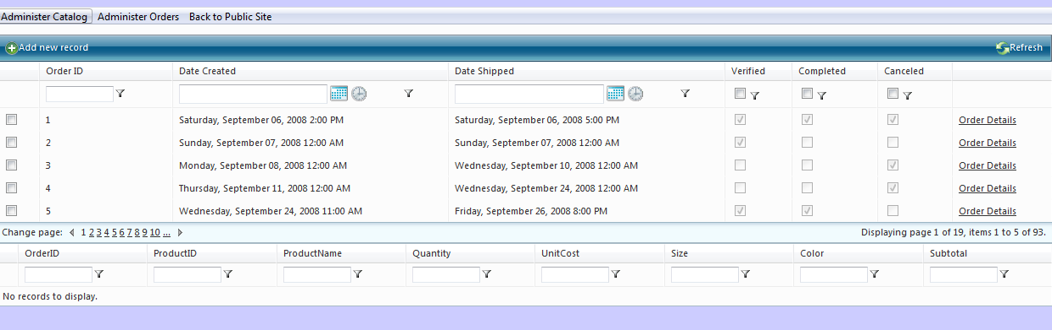 OrdersAdmin.aspx maintains information about the order itself, such as who ordered it and what was sent. Two RadGrids were used to display this information. One queries the orders table and the other one queries the order details table. The second grid is populated based on a query string provided by the first grid’s hyperlink column.

Configuration
This module reads all properties from the section group, so that these values can be checked before fed into LinqCommerce. The Utilities.cs file also e-mails errors to an e-mail address specified in the Web.config. If any other error logged is necessary, it is recommended that it is implemented in this file. As an alternative, you could also use health monitoring.

Web.config Demystified
The Web.config has these main parts:

Section Group Element Properties
These control properties such as cart persist days and your PayPal e-mail account. Here is a full listing of the fields that need to be added to your Web.config:
Key Name | Description | Sample Value
MailServer | This is the mail server used for your application to send e-mails | Smtp.mysite.com
EnableErrorLogEmail | This enables error logging in LinqCommerce | Boolean
ErrorLogEMail | This is the e-mail where the error messages get sent | joe@yahoo.com
SiteName | This is the name of your site and this can be used in some page properties | BalloonShop
CartPersistDays | This is the number of days that your shopping cart will stay in the database before it is automatically deleted. | An integer such as 10 or 11
URLReturn | This is the URL PayPal will send the user after the payment has been processed | A URL like http://www.yahoo.com
URLCancel | This is the URL PayPal will send the user if he or she cancels the order | A URL like http://www.yahoo.com
PayPalHeaderImage | On the top of the order processing page, this is your company logo | A location of an image on the internet like http://www.yahoo.com/mypicture.jpg
PayPalEMailAccount | This is the e-mail account that you use for PayPal | An e-mail like joe@yahoo.com
APILogin | This is the login for Authorize.NET | 10 characters long, alpha numeric
Transaction Key | This is a special key that Authrorize.NET gives you, similar to a password | 20 character long, alpha numeric
PayPalEnvironment | Either sandbox or live, sets whether you’re testing or in production

Installation

Installing Sitefinity CMS or ASP.NET Application
Information on installing the Sitefinity CMS can be found in its own Installation Manual. Once Sitefinity is installed, you need to copy all of the files from the LinqCommerce web site into the Sitefinity website, then you must adjust the Web.config. You must also run the database scripts, which is detailed below this paragraph.

Configuration
Follow these steps to set-up the Web.config file for the application:

- Add this code to your Web.config:

<section name="performanceCounter" type="Telerik.Framework.Utilities.HealthMonitoring.Configuration.CountersSection, Telerik.Framework" />
<section name="storageSetting" type="Telerik.Libraries.AmazonStorage.StorageSection, Telerik.Libraries" requirePermission="false" />
<section name="mediaProvider" type="Telerik.Libraries.MediaProvider.Configuration.MediaProviderSection, Telerik.Libraries" requirePermission="false" />
</sectionGroup>
<!--End of Telerik Section Group-->
<!--Insert LinqCommerce Section Groups Here-->
<sectionGroup name="LinqCommerce" type="LinqCommerce.SectionConfigurationGroup">
<section name="Payment" type="LinqCommerce.SectionConfigurationGroup"/>
<section name="SiteSettings" type="LinqCommerce.SectionConfigurationGroup"/>
<section name="AmazonSettings" type="LinqCommerce.SectionConfigurationGroup"/>
<section name="AuthorizeNETSettings" type="LinqCommerce.SectionConfigurationGroup"/>
</sectionGroup>

<storageSetting defaultProvider="Amazon">
<providers>
<add name="Amazon" type="Telerik.Libraries.AmazonStorage.AmazonStorageProvider, Telerik.Libraries" downloadUrlPrefix="http://s3.amazonaws.com" accessKey="#YourAccessKey#" secretAccessKey="#YourSecrectKey#" bucketName="Sitefinity" />
</providers>
</storageSetting>
<!-- Viddler-->
<mediaProvider defaultProvider="viddler">
<providers>
<add name="viddler" type="Telerik.Libraries.MediaProvider.ViddlerProvider" apiKey="#Your_Api#" baseUrl="http://api.viddler.com/rest/v1/" />
</providers>
</mediaProvider>
</telerik>
<!--End of Telerik Section Group-->
<!--Insert LinqCommerce Section Group Here-->
<LinqCommerce>
<Payment>
<PayPal PayPalEMailAccount="" URLReturn="http://www.yahoo.com" URLCancel="http://www.google.com" PayPalHeaderImage=""></PayPal>
</Payment>
<SiteSettings>
<ErrorHandlingSettings MailServer="" EnableErrorLogEmail="true" ErrorLogEmail="" ErrorLogEmailFrom=""></ErrorHandlingSettings>
<ShoppingCartSettings RecentProducts="-100" SiteName="BalloonShop" CartPersistDays="10"></ShoppingCartSettings>
</SiteSettings>
<AuthorizeNETSettings>
<AuthorizeNET APILogin="" TransactionKey="">
</AuthorizeNET>
</AuthorizeNETSettings>
</LinqCommerce>

- Add a second connection string called BalloonShop to your Web.config, which should look something like this:
<connectionString>
<add name="BalloonShop" connectionString="Data Source=JOSEPH\SQLEXPRESS;Initial Catalog=BalloonShop;Integrated Security=True" providerName="System.Data.SqlClient"/>
</connectionString>
Please note that the DBML file is seeking a connection string by this name, since LinqCommerce is an adjustment from another module as I said above.
- Add these highlighted lines below the profile provider:

<add name="Sitefinity" connectionStringName="DefaultConnection" applicationName="/" type="Telerik.DataAccess.AspnetProviders.TelerikProfileProvider, Telerik.DataAccess"/>
</providers>
<properties>
<add name="FirstName"/>
<add name="LastName"/>
<add name="MiddleName"/>
<add name="Prefix"/>
<add name="NickName"/>
<add name="Address"/>
<add name="Address2"/>
<add name="City"/>
<add name="State"/>
<add name="Zip"/>
<add name="Phone"/>
<add name="Fax"/>
<add name="Country"/>
<group name="Billing">
<add name="FirstName"/>
<add name="LastName"/>
<add name="MiddleName"/>
<add name="Prefix"/>
<add name="NickName"/>
<add name="Address"/>
<add name="Address2"/>
<add name="City"/>
<add name="State"/>
<add name="Zip"/>
<add name="Phone"/>
<add name="Fax"/>
<add name="Country"/>
</group>
<group name="Shipping">
<add name="FirstName"/>
<add name="LastName"/>
<add name="MiddleName"/>
<add name="Prefix"/>
<add name="NickName"/>
<add name="Address"/>
<add name="Address2"/>
<add name="City"/>
<add name="State"/>
<add name="Zip"/>
<add name="Phone"/>
<add name="Fax"/>
<add name="Country"/>
</group>
</properties>

Database
LinqCommerce needs several database tables to function properly. Please download the database scripts, then run them on an existing database. Here are the steps to run scripts:
  - Go to Start > All Programs > SQL Server Management Studio 2005 (or 2008)
  - Login using your credentials
  - On the top left, click new query
  - Copy and paste all of the database scripts into the white box in the middle
  - From the database drop down, select your database
  - Click the red “!” button
Your database is now prepared to use LinqCommerce.

Membership, Roles and Profiles
If you’re using Sitefinity, then skip this section.
You can use the ASPNETDB.mdf with LinqCommerce. Then, you can set-up roles and users using that database. For more info, please go Website > ASP.NET Configuration in Visual Studio.

Connection String
Please note that no connection string has been set for this project, but the name of the connection string must be balloonshop, since the starter kit was adjusted from this book by Christian Darie. The scripts for the database are in the App_Data folder.

PayPal Integration
Before you can integrate PayPal, however, you must sign up for a PayPal Premier Account and Website Payment Standard. PayPal also offers other payment options for larger sites with more features, so you can sign up for these additional features if your customer requires them. I would also recommend reading PayPal’s extensive documentation on Website Payment Standard and their Sandbox Environment.

Amazon Access ID
To retrieve product recommendations from Amazon, you'll need an Amazon Access ID. Sign up on this site to get one.

Amazon Search Index
These are the various sections of Amazon.com. By default, the value toys is used and other ones can be inserted. For more info, check out Amazon's webpage.

Amazon Associates
My API for Amazon Associates has been compiled and included in this project. To see its source, please visit my CodePlex project.

Best Buy Remix API
LinqCommerce can be integrated with Best Buy’s Remix API. This is like Amazon Associates, but you can advertise Best Buy products to sell. For more info, please visit my CodePlex project.

After the Order Has Been Placed
LinqCommerce has been integrated with PayPal Website Payments Standard and Google Checkout. LinqCommerce sends these payment systems an order ID, an order name, a quantity of 1 (there is only 1 order), and a total for the order. Once the order is complete, both systems with use a payment notification system to contact LinqCommerce, using listeners which are included with the system in the ~/Files directory. LinqCommerce reads an OrderID from both of these payment providers, finds it in the system, and marks it as complete. For more info on these systems, consult these links:
PayPal IPN
Google Checkout Notification API

Google Checkout
LinqCommerce has been integrated with Google Checkout. You will need an API key from Google to use that checkout system. For more info on obtaining one, please refer to this article.

Tutorials

Getting Started with the Admin

Introduction

This article describes how an end user can insert departments, categories and products into LinqCommerce. This article also describes how to administer orders, tax and coupons.

Adding Products to the Admin

Navigate to http://www.[nameofyoursite].com/linqcontrols/admin/catalogadmin.aspx to use the product admin. From here, insert a department. Then, click on view categories and enter in a category on the next page.
Next, go to Administer Catalog > Administer Departments… > Add a Product. Complete the form. By checking off on department or on catalog promotion, the product will appear when there are no departments (on dept. promotion) or no categories (on catalog promotion) selected. For now, do not check the size and color checkboxes.
Next, go to Administer Catalog > Administer Departments… > View/Edit All Products. Filter for your products in the name column. Then, click Add/Edit Pictures/Categories. On the next screen, add categories to the product and add images. When this is complete, click Back to Public Site on the menu.

Tax and Shipping
If you aren’t use Authorize.NET, you can ignore this section. Now that this is complete, you need to configure tax and shipping, so click on Tax Admin in the top menu. On the first RadGrid, insert a record with a name of MA and a tax of 5. This will tax anyone 5% extra if their billing state is Massachusetts. On the second RadGrid, insert a record called [Select One] and a value of 0. Then, insert a record called United States and 5. This will populate the shipping drop down on the shopping cart with those options. Here is an example of what the data should look like:
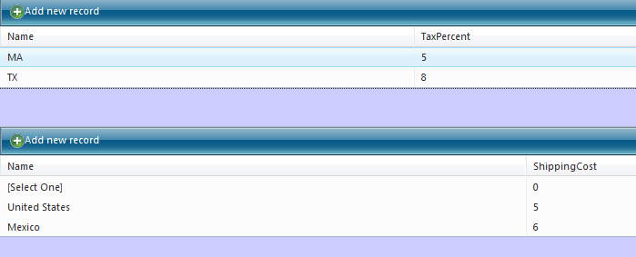

Coupons
Once this is done, let’s add a coupon. Click on Administer Orders > Coupon Admin. Enter in a record as shown below this sentence:
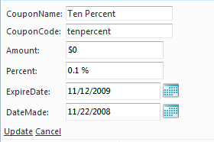
The code is what the user enters to receive the discount in the shopping cart. The amount is the cash amount discount, which must be a negative number to remove money from an order, and the percent is the percent discount. Expire date would tell the system that this coupon expires on that date and date made is the date you made the coupon. Now that this is complete, you need to order some products from your supplier, so that the system will allow you to add products to the cart.

Inventory
In the admin, click on Inventory > Seller List. Add a seller to the RadGrid. Then, click on Inventory > Add Product Orders. Select the product that you added and complete the form. Then, click on Inventory > View Inventory to see what’s in stock:
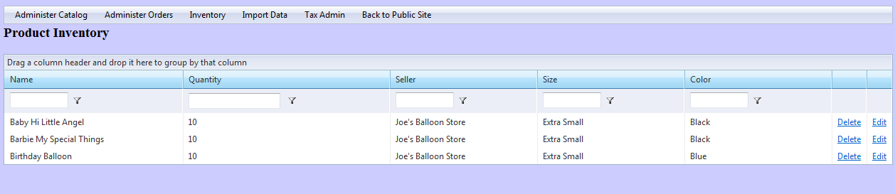

Conclusion
Users can add products by adding a department, a category and product meta data. The admin must also order products and insert that order into the admin. Coupons, tax and shipping info can also be added via the admin.

